**Topic:** Causes of WW1

**Images:**

1. <http://www.bbc.co.uk/schools/gcsebitesize/history/mwh/ir1/schlieffenplanrev3.shtml>

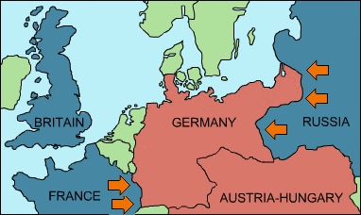

1. <https://commons.wikimedia.org/wiki/File:Minutos_previos_al_atentado_en_Sarajevo.jpg>

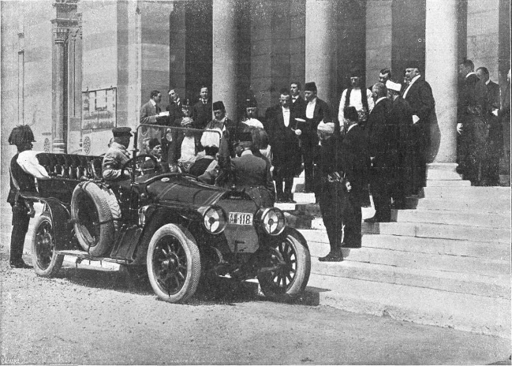

**Videos:**

1. <https://youtu.be/S-wSL4WqUws>
2. <https://youtu.be/kyCmh9G1fpo>
3. <https://youtu.be/zroZqvr4whk>
4. <https://youtu.be/WukYrrTH3ms>

**Notes:**

* MANIA
* Militarism: The idea that a country needs a really strong military to achieve things.
  + There was a race between Germany and Great Britain to see who had a better naval military.
    - the Naval Race
* Alliances: Agreements between nations to help each other.
  + A man named Otto von Bismarck tried to make several alliances with other countries to help his country, Germany.
  + Most of these alliances did not work out.
* Nationalism: A feeling of extreme pride towards the country you live in.
* Imperialism: When one country takes over another (economically + politically)
* Assassination: The Archduke Franz Ferdinand was assassinated June 28, 1914 on his way to a city called Sarajevo.
  + The group of people that killed the Archduke were from Serbia.
  + This made his country, Austria, upset at Serbia.
    - wanted to fight
* The country Germany was scared that two other countries, Russia and France, would make an alliance and attack Germany.
  + Germany created the Schlieffen Plan to attack France and Russia before Germany was attacked.